**Master Functional Document**

|  |  |
| --- | --- |
| **Application** | NGERP - Centra |
| **Service Bundle** | Master Management |
| **Service Request** | User |

**Description :**

User master is used to create the user which is used for login. The user has access to the application defined in the role in which the user is mapped.

**Workflow Process :**

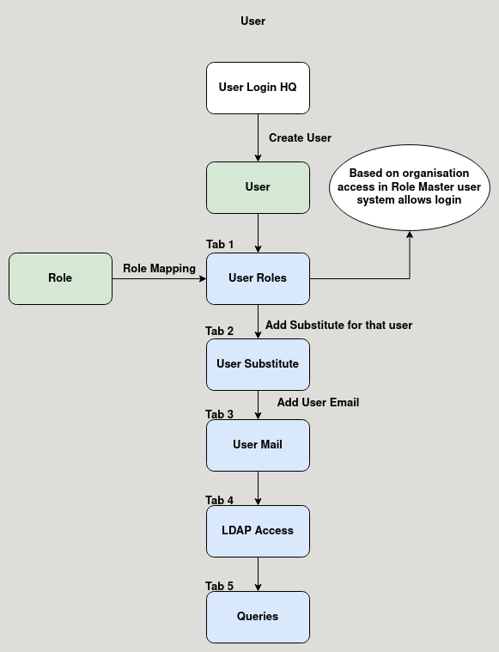

**Business Rules :**

* user can be only created in HQ.
* The user master is used to create user for the application which is used to login into the application.
* After creating the user the user is mapped to a role in the User Role tab.
* The user has all the access defined in the user Role master.
* There are five tabs in user master:
  + User Role
  + User Substitute
  + User Mail
  + LDAP Access
  + Queries
* User Role:

This tab is used to map the role to the user from role master.

* User Substitute:

Substitute can be maped the user in this tab.

* User Mail:

User Mail can be added in this tab.